Slip 1

DOT NET

Public Class Form1

Dim counter As Integer

Private Sub Form1_Load(sender As Object, e As EventArgs) Handles MyBase.Load

counter = 0

End Sub

Private Sub Button1_Click(sender As Object, e As EventArgs) Handles Button1.Click

counter = counter + 1

txt1.Text = counter

End Sub

End Class

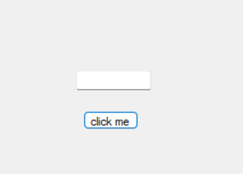

B)

Imports System.Data.SqlClient

Public Class Form1

Dim con As New SqlConnection("Data Source=LAPTOP-LG7D95UU\SQLEXPRESS;Initial Catalog=employee;Integrated Security=True")

Dim adpt As New SqlDataAdapter("Select * from Emp", con)

Dim ds As New DataSet

Dim cmd As New SqlCommand

Public Function display()

adpt.Fill(ds, "Emp")

DataGridView1.DataSource = ds

DataGridView1.DataMember = "Emp"

Return ds

End Function

Private Sub Form1_Load(sender As Object, e As EventArgs) Handles MyBase.Load

display()

End Sub

Private Sub Button1_Click(sender As Object, e As EventArgs) Handles Button1.Click

cmd.Connection = con

cmd.CommandType = CommandType.Text

cmd.CommandText = "INSERT INTO Emp values(@eno, @ename, @esalary)"

cmd.Parameters.AddWithValue("@eno", TextBox1.Text)

cmd.Parameters.AddWithValue("@ename", TextBox2.Text)

cmd.Parameters.AddWithValue("@esalary", TextBox3.Text)

con.Open()

cmd.ExecuteNonQuery()

con.Close()

ds.Clear()

display()

End Sub

End Class

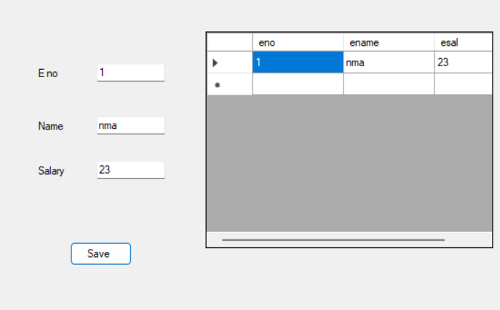

Slip no 17

A)

using System;

class Program

{

static void Main(string[] args)

{

Console.WriteLine("Enter a string:");

string input = Console.ReadLine();

Console.WriteLine("Vowels in the given string:");

foreach (char c in input)

{

if (IsVowel(c))

{

Console.Write(c + " ");

}

}

Console.ReadLine(); // Keeps console window open until Enter is pressed

}

static bool IsVowel(char c)

{

// Convert character to lowercase for case-insensitive comparison

char lowerCase = char.ToLower(c);

// Check if the character is a vowel

return lowerCase == 'a' || lowerCase == 'e' || lowerCase == 'i' || lowerCase == 'o' || lowerCase == 'u';

}

}

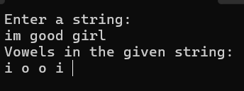

B)

Imports System.Data.SqlClient

Public Class Form1

Dim con As New SqlConnection("Data Source=LAPTOP-LG7D95UU\SQLEXPRESS;Initial Catalog=pro;Integrated Security=True")

Dim adpt As New SqlDataAdapter("Select * from product", con)

Dim ds As New DataSet

Dim cmd As New SqlCommand

Public Function display()

adpt.Fill(ds, "product")

DataGridView1.DataSource = ds

DataGridView1.DataMember = "product"

Return ds

End Function

Private Sub Form1_Load(sender As Object, e As EventArgs) Handles MyBase.Load

'TODO: This line of code loads data into the 'ProDataSet.product' table. You can move, or remove it, as needed.

Me.ProductTableAdapter.Fill(Me.ProDataSet.product)

display()

End Sub

Private Sub Button1_Click(sender As Object, e As EventArgs) Handles Button1.Click

cmd.Connection = con

cmd.CommandType = CommandType.Text

cmd.CommandText = "INSERT INTO product values(@pno,@pname, @exp, @price)"

cmd.Parameters.AddWithValue("@pno", TextBox1.Text)

cmd.Parameters.AddWithValue("@pname", TextBox2.Text)

cmd.Parameters.AddWithValue("@exp", TextBox3.Text)

cmd.Parameters.AddWithValue("@price", TextBox3.Text)

con.Open()

cmd.ExecuteNonQuery()

con.Close()

ds.Clear()

display()

End Sub

End Class

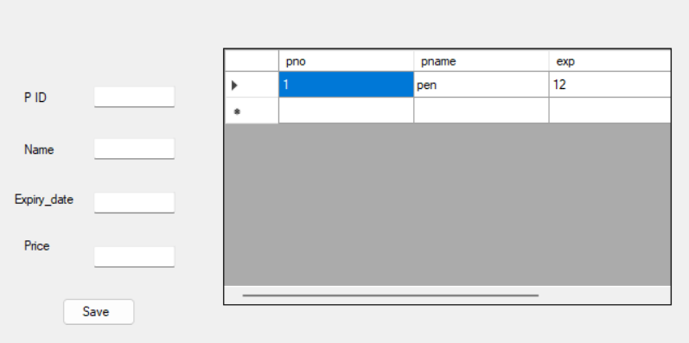

Slip no 24

A)

using System;

class Program

{

static void Main(string[] args)

{

Console.WriteLine("Enter a number:");

int number = Convert.ToInt32(Console.ReadLine());

bool isPrime = IsPrime(number);

Console.WriteLine($"{number} is {(isPrime ? "prime" : "not prime")}.");

Console.ReadLine(); // Keeps console window open until Enter is pressed

}

static bool IsPrime(int number)

{

if (number <= 1) return false;

if (number <= 3) return true;

if (number % 2 == 0 || number % 3 == 0) return false;

for (int i = 5; i * i <= number; i += 6)

{

if (number % i == 0 || number % (i + 2) == 0) return false;

}

return true;

}

}

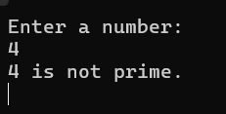

B)

Imports System.Data.SqlClient

Public Class Form1

Dim con As New SqlConnection("Data Source=LAPTOP-LG7D95UU\SQLEXPRESS;Initial Catalog=author;Integrated Security=True")

Dim adpt As New SqlDataAdapter("Select * from Aut", con)

Dim ds As New DataSet

Dim cmd As New SqlCommand

Public Function display()

adpt.Fill(ds, "Aut")

DataGridView1.DataSource = ds

DataGridView1.DataMember = "Aut"

Return ds

End Function

Private Sub Form1_Load(sender As Object, e As EventArgs) Handles MyBase.Load

'TODO: This line of code loads data into the 'AuthorDataSet.Aut' table. You can move, or remove it, as needed.

Me.AutTableAdapter.Fill(Me.AuthorDataSet.Aut)

display()

End Sub

Private Sub Button1_Click(sender As Object, e As EventArgs) Handles Button1.Click

cmd.Connection = con

cmd.CommandType = CommandType.Text

cmd.CommandText = "INSERT INTO Aut values(@aid, @aname, @bookname)"

cmd.Parameters.AddWithValue("@aid", TextBox1.Text)

cmd.Parameters.AddWithValue("@aname", TextBox2.Text)

cmd.Parameters.AddWithValue("@bookname", TextBox3.Text)

con.Open()

cmd.ExecuteNonQuery()

con.Close()

ds.Clear()

display()

End Sub

Private Sub Button2_Click(sender As Object, e As EventArgs) Handles Button2.Click

cmd.Connection = con

cmd.CommandType = CommandType.Text

cmd.CommandText = "DELETE FROM Aut WHERE bookname='" & TextBox3.Text & "'"

con.Open()

If cmd.ExecuteNonQuery() Then

MessageBox.Show("Deleted Successfully...!")

End If

con.Close()

ds.Clear()

display()

End Sub

End Class

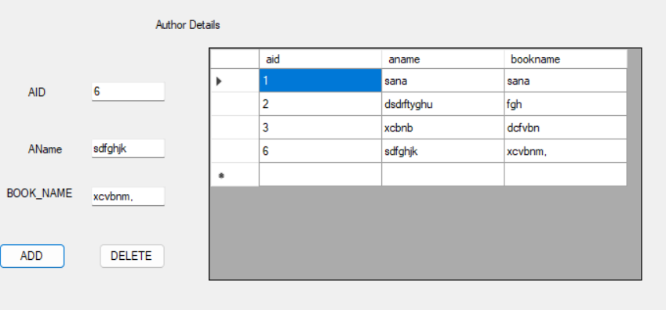

ADV JAVA

SLIP NO 1



import javax.swing.*;

import java.awt.*;

import java.awt.event.*;

public class scroll extends JPanel implements Runnable {

private String msg = "Welcome to Java Programming Language ....... ";

private Thread t;

private volatile boolean running = true;

public scroll() {

setBackground(Color.CYAN);

setForeground(Color.RED);

t = new Thread(this);

t.start();

}

public void run() {

while (running) {

try {

repaint();

Thread.sleep(400);

char ch = msg.charAt(0);

msg = msg.substring(1) + ch;

} catch (InterruptedException e) {

e.printStackTrace();

}

}

}

@Override

protected void paintComponent(Graphics g) {

super.paintComponent(g);

g.drawString(msg, 10, 10);

}

public static void main(String[] args) {

JFrame frame = new JFrame("Scrolling Message");

scroll scroll = new scroll();

frame.add(scroll);

frame.setSize(400, 200);

frame.setDefaultCloseOperation(JFrame.EXIT_ON_CLOSE);

frame.setVisible(true);

}

}

B)

Server.java

package chatting.application;

import javax.swing.*;

import javax.swing.border.*;

import java.awt.*;

import java.awt.event.*;

import java.util.*;

import java.text.*;

import java.net.*;

import java.io.*;

public class Server implements ActionListener {

JTextField text;

JPanel a1;

static Box vertical = Box.createVerticalBox();

static JFrame f = new JFrame();

static DataOutputStream dout;

Server() {

f.setLayout(null);

JPanel p1 = new JPanel();

p1.setBackground(new Color(7, 94, 84));

p1.setBounds(0, 0, 450, 70);

p1.setLayout(null);

f.add(p1);

ImageIcon i1 = new ImageIcon(ClassLoader.getSystemResource("icons/3.png"));

Image i2 = i1.getImage().getScaledInstance(25, 25, Image.SCALE_DEFAULT);

ImageIcon i3 = new ImageIcon(i2);

JLabel back = new JLabel(i3);

back.setBounds(5, 20, 25, 25);

p1.add(back);

back.addMouseListener(new MouseAdapter() {

public void mouseClicked(MouseEvent ae) {

System.exit(0);

}

});

ImageIcon i4 = new ImageIcon(ClassLoader.getSystemResource("icons/1.png"));

Image i5 = i4.getImage().getScaledInstance(50, 50, Image.SCALE_DEFAULT);

ImageIcon i6 = new ImageIcon(i5);

JLabel profile = new JLabel(i6);

profile.setBounds(40, 10, 50, 50);

p1.add(profile);

ImageIcon i7 = new ImageIcon(ClassLoader.getSystemResource("icons/video.png"));

Image i8 = i7.getImage().getScaledInstance(30, 30, Image.SCALE_DEFAULT);

ImageIcon i9 = new ImageIcon(i8);

JLabel video = new JLabel(i9);

video.setBounds(300, 20, 30, 30);

p1.add(video);

ImageIcon i10 = new ImageIcon(ClassLoader.getSystemResource("icons/phone.png"));

Image i11 = i10.getImage().getScaledInstance(35, 30, Image.SCALE_DEFAULT);

ImageIcon i12 = new ImageIcon(i11);

JLabel phone = new JLabel(i12);

phone.setBounds(360, 20, 35, 30);

p1.add(phone);

ImageIcon i13 = new ImageIcon(ClassLoader.getSystemResource("icons/3icon.png"));

Image i14 = i13.getImage().getScaledInstance(10, 25, Image.SCALE_DEFAULT);

ImageIcon i15 = new ImageIcon(i14);

JLabel morevert = new JLabel(i15);

morevert.setBounds(420, 20, 10, 25);

p1.add(morevert);

JLabel name = new JLabel("Gaitonde");

name.setBounds(110, 15, 100, 18);

name.setForeground(Color.WHITE);

name.setFont(new Font("SAN_SERIF", Font.BOLD, 18));

p1.add(name);

JLabel status = new JLabel("Active Now");

status.setBounds(110, 35, 100, 18);

status.setForeground(Color.WHITE);

status.setFont(new Font("SAN_SERIF", Font.BOLD, 14));

p1.add(status);

a1 = new JPanel();

a1.setBounds(5, 75, 440, 570);

f.add(a1);

text = new JTextField();

text.setBounds(5, 655, 310, 40);

text.setFont(new Font("SAN_SERIF", Font.PLAIN, 16));

f.add(text);

JButton send = new JButton("Send");

send.setBounds(320, 655, 123, 40);

send.setBackground(new Color(7, 94, 84));

send.setForeground(Color.WHITE);

send.addActionListener(this);

send.setFont(new Font("SAN_SERIF", Font.PLAIN, 16));

f.add(send);

f.setSize(450, 700);

f.setLocation(200, 50);

f.setUndecorated(true);

f.getContentPane().setBackground(Color.WHITE);

f.setVisible(true);

}

public void actionPerformed(ActionEvent ae) {

try {

String out = text.getText();

JPanel p2 = formatLabel(out);

a1.setLayout(new BorderLayout());

JPanel right = new JPanel(new BorderLayout());

right.add(p2, BorderLayout.LINE_END);

vertical.add(right);

vertical.add(Box.createVerticalStrut(15));

a1.add(vertical, BorderLayout.PAGE_START);

dout.writeUTF(out);

text.setText("");

f.repaint();

f.invalidate();

f.validate();

} catch (Exception e) {

e.printStackTrace();

}

}

public static JPanel formatLabel(String out) {

JPanel panel = new JPanel();

panel.setLayout(new BoxLayout(panel, BoxLayout.Y_AXIS));

JLabel output = new JLabel("<html><p style=\"width: 150px\">" + out + "</p></html>");

output.setFont(new Font("Tahoma", Font.PLAIN, 16));

output.setBackground(new Color(37, 211, 102));

output.setOpaque(true);

output.setBorder(new EmptyBorder(15, 15, 15, 50));

panel.add(output);

Calendar cal = Calendar.getInstance();

SimpleDateFormat sdf = new SimpleDateFormat("HH:mm");

JLabel time = new JLabel();

time.setText(sdf.format(cal.getTime()));

panel.add(time);

return panel;

}

public static void main(String[] args) {

new Server();

try {

ServerSocket skt = new ServerSocket(6001);

while(true) {

Socket s = skt.accept();

DataInputStream din = new DataInputStream(s.getInputStream());

dout = new DataOutputStream(s.getOutputStream());

while(true) {

String msg = din.readUTF();

JPanel panel = formatLabel(msg);

JPanel left = new JPanel(new BorderLayout());

left.add(panel, BorderLayout.LINE_START);

vertical.add(left);

f.validate();

}

}

} catch (Exception e) {

e.printStackTrace();

}

}

}

Client.java

package chatting.application;

import javax.swing.*;

import javax.swing.border.*;

import java.awt.*;

import java.awt.event.*;

import java.util.*;

import java.text.*;

import java.net.*;

import java.io.*;

public class Client implements ActionListener {

JTextField text;

static JPanel a1;

static Box vertical = Box.createVerticalBox();

static JFrame f = new JFrame();

static DataOutputStream dout;

Client() {

f.setLayout(null);

JPanel p1 = new JPanel();

p1.setBackground(new Color(7, 94, 84));

p1.setBounds(0, 0, 450, 70);

p1.setLayout(null);

f.add(p1);

ImageIcon i1 = new ImageIcon(ClassLoader.getSystemResource("icons/3.png"));

Image i2 = i1.getImage().getScaledInstance(25, 25, Image.SCALE_DEFAULT);

ImageIcon i3 = new ImageIcon(i2);

JLabel back = new JLabel(i3);

back.setBounds(5, 20, 25, 25);

p1.add(back);

back.addMouseListener(new MouseAdapter() {

public void mouseClicked(MouseEvent ae) {

System.exit(0);

}

});

ImageIcon i4 = new ImageIcon(ClassLoader.getSystemResource("icons/2.png"));

Image i5 = i4.getImage().getScaledInstance(50, 50, Image.SCALE_DEFAULT);

ImageIcon i6 = new ImageIcon(i5);

JLabel profile = new JLabel(i6);

profile.setBounds(40, 10, 50, 50);

p1.add(profile);

ImageIcon i7 = new ImageIcon(ClassLoader.getSystemResource("icons/video.png"));

Image i8 = i7.getImage().getScaledInstance(30, 30, Image.SCALE_DEFAULT);

ImageIcon i9 = new ImageIcon(i8);

JLabel video = new JLabel(i9);

video.setBounds(300, 20, 30, 30);

p1.add(video);

ImageIcon i10 = new ImageIcon(ClassLoader.getSystemResource("icons/phone.png"));

Image i11 = i10.getImage().getScaledInstance(35, 30, Image.SCALE_DEFAULT);

ImageIcon i12 = new ImageIcon(i11);

JLabel phone = new JLabel(i12);

phone.setBounds(360, 20, 35, 30);

p1.add(phone);

ImageIcon i13 = new ImageIcon(ClassLoader.getSystemResource("icons/3icon.png"));

Image i14 = i13.getImage().getScaledInstance(10, 25, Image.SCALE_DEFAULT);

ImageIcon i15 = new ImageIcon(i14);

JLabel morevert = new JLabel(i15);

morevert.setBounds(420, 20, 10, 25);

p1.add(morevert);

JLabel name = new JLabel("Bunty");

name.setBounds(110, 15, 100, 18);

name.setForeground(Color.WHITE);

name.setFont(new Font("SAN_SERIF", Font.BOLD, 18));

p1.add(name);

JLabel status = new JLabel("Active Now");

status.setBounds(110, 35, 100, 18);

status.setForeground(Color.WHITE);

status.setFont(new Font("SAN_SERIF", Font.BOLD, 14));

p1.add(status);

a1 = new JPanel();

a1.setBounds(5, 75, 440, 570);

f.add(a1);

text = new JTextField();

text.setBounds(5, 655, 310, 40);

text.setFont(new Font("SAN_SERIF", Font.PLAIN, 16));

f.add(text);

JButton send = new JButton("Send");

send.setBounds(320, 655, 123, 40);

send.setBackground(new Color(7, 94, 84));

send.setForeground(Color.WHITE);

send.addActionListener(this);

send.setFont(new Font("SAN_SERIF", Font.PLAIN, 16));

f.add(send);

f.setSize(450, 700);

f.setLocation(800, 50);

f.setUndecorated(true);

f.getContentPane().setBackground(Color.WHITE);

f.setVisible(true);

}

public void actionPerformed(ActionEvent ae) {

try {

String out = text.getText();

JPanel p2 = formatLabel(out);

a1.setLayout(new BorderLayout());

JPanel right = new JPanel(new BorderLayout());

right.add(p2, BorderLayout.LINE_END);

vertical.add(right);

vertical.add(Box.createVerticalStrut(15));

a1.add(vertical, BorderLayout.PAGE_START);

dout.writeUTF(out);

text.setText("");

f.repaint();

f.invalidate();

f.validate();

} catch (Exception e) {

e.printStackTrace();

}

}

public static JPanel formatLabel(String out) {

JPanel panel = new JPanel();

panel.setLayout(new BoxLayout(panel, BoxLayout.Y_AXIS));

JLabel output = new JLabel("<html><p style=\"width: 150px\">" + out + "</p></html>");

output.setFont(new Font("Tahoma", Font.PLAIN, 16));

output.setBackground(new Color(37, 211, 102));

output.setOpaque(true);

output.setBorder(new EmptyBorder(15, 15, 15, 50));

panel.add(output);

Calendar cal = Calendar.getInstance();

SimpleDateFormat sdf = new SimpleDateFormat("HH:mm");

JLabel time = new JLabel();

time.setText(sdf.format(cal.getTime()));

panel.add(time);

return panel;

}

public static void main(String[] args) {

new Client();

try {

Socket s = new Socket("127.0.0.1", 6001);

DataInputStream din = new DataInputStream(s.getInputStream());

dout = new DataOutputStream(s.getOutputStream());

while(true) {

a1.setLayout(new BorderLayout());

String msg = din.readUTF();

JPanel panel = formatLabel(msg);

JPanel left = new JPanel(new BorderLayout());

left.add(panel, BorderLayout.LINE_START);

vertical.add(left);

vertical.add(Box.createVerticalStrut(15));

a1.add(vertical, BorderLayout.PAGE_START);

f.validate();

}

} catch (Exception e) {

e.printStackTrace();

}

}

}

SLIP NO 17

A)

import java.util.*;

class ThreadVowel1 extends Thread

{

String v;

ThreadVowel1(String k)

{

v=k;

}

public void run()

{

for(int i=0;i<v.length();i++)

{

if( v.charAt(i)=='a' ||v.charAt(i)=='e' ||v.charAt(i)=='i' ||v.charAt(i)=='o'||v.charAt(i)=='u')

{

System.out.println(v.charAt(i));

try

{

Thread.sleep(3000);

}

catch(Exception e){}

}

}

}

}

public class vow

{

public static void main(String args[])

{

Scanner sc=new Scanner(System.in);

System.out.println("Enter a string");

String n=sc.next();

ThreadVowel1 tv=new ThreadVowel1(n);

tv.start();

}

}

B)

:

Server file

import java.io.*;

import java.net.*;

public class Server {

public static void main(String[] args) throws Exception {

ServerSocket ss = new ServerSocket(5400);

while (true) {

Socket s = ss.accept();

DataOutputStream dos = new DataOutputStream(s.getOutputStream());

File f = new File("E:\addvans-java\src\jsp\server.text");

if (f.exists()) {

Scanner sc = new Scanner(f);

while (sc.hasNextLine()) {

String str = sc.nextLine();

dos.writeUTF(f.getName() + " = file content = " + str);

}

} else {

String stra = "file is not Exists on SERVER";

dos.writeUTF(" Error -- " + stra);

}

}

}

}

client file

import java.net.*;

import java.io.*;

public class Client {

public static void main(String[] args) throws IOException {

Socket s = new Socket("localhost", 5400);

DataInputStream dis = new DataInputStream(s.getInputStream());

System.out.print("result = ");

System.out.print(dis.readUTF());

    }

}

SLIP NO 24

A)

index.html

<html>

<head>

<meta charset="UTF-8">

<title>Number to Words Converter</title>

<style>

.red-text {

color: red;

}

</style>

</head>

<body>

<h1>Number to Words Converter</h1>

<form action="qwe.jsp" method="post">

<label for="number">Enter a number:</label>

<input type="text" id="number" name="number" />

<br /><br />

<input type="submit" value="Convert to Words" />

</form>

</body>

</html>

qwe.jsp

<%@page contentType="text/html" pageEncoding="UTF-8"%>

<% if (request.getParameter("number") != null) { %>

<%-- Convert the number to words --%>

<%String number = request.getParameter("number");

String[] words = {"Zero", "One", "Two", "Three", "Four", "Five", "Six", "Seven", "Eight", "Nine"};

String result = "";

for (int i = 0; i < number.length(); i++) {

int digit = Character.getNumericValue(number.charAt(i));

result += words[digit] + " ";

}

out.println("result="+result);

%>

<%-- Display the result in red color --%>

<% } %>

B)

import java.util.Scanner;

public class EmpTable {

public static void main(String[] args) {

Scanner scanner = new Scanner(System.in);

int choice;

do {

System.out.println("\nEmp Table Menu:");

System.out.println("1. Insert record");

System.out.println("2. Update record");

System.out.println("3. Delete record");

System.out.println("4. Search by ENo");

System.out.println("0. Exit");

System.out.print("Enter your choice: ");

choice = scanner.nextInt();

switch (choice) {

case 1:

insertRecord();

break;

case 2:

updateRecord();

break; case 3:

employee.java import java.util.Scanner;

public class EmpTable {

public static void main(String[] args) {

Scanner scanner = new Scanner(System.in);

int choice;

do {

System.out.println("\nEmp Table Menu:");

System.out.println("1. Insert record");

System.out.println("2. Update record");

System.out.println("3. Delete record");

System.out.println("4. Search by ENo");

System.out.println("0. Exit");

System.out.print("Enter your choice: ");

choice = scanner.nextInt();

switch (choice) {

case 1:

insertRecord();

break;

case 2:

updateRecord();

break; case 3:

deleteRecord();

break;

case 4:

searchRecord();

break;

case 0:

System.out.println("Exiting...");

break;

default:

System.out.println("Invalid choice, please try again.");

}

} while (choice != 0);

scanner.close();

}

private static void insertRecord() {

Scanner scanner = new Scanner(System.in);

System.out.print("Enter ENo: ");

int ENo = scanner.nextInt();

System.out.print("Enter EName: ");

String EName = scanner.next();

System.out.print("Enter salary: ");

double salary = scanner.nextDouble();

System.out.print("Enter Desg: ");

String Desg = scanner.next();

// TODO: Add code to insert record into Emp table

System.out.println("Record inserted successfully.");

}private static void updateRecord() {

Scanner scanner = new Scanner(System.in);

System.out.print("Enter ENo to update: ");

int ENo = scanner.nextInt();

// TODO: Check if record with ENo exists

System.out.print("Enter new EName: ");

String EName = scanner.next();

System.out.print("Enter new salary: ");

double salary = scanner.nextDouble();

System.out.print("Enter new Desg: ");

String Desg = scanner.next();

// TODO: Add code to update record in Emp table

System.out.println("Record updated successfully.");

}

private static void deleteRecord() {

Scanner scanner = new Scanner(System.in);

System.out.print("Enter ENo to delete: ");

int ENo = scanner.nextInt();

// TODO: Check if record with ENo exists

// TODO: Add code to delete record from Emp table

System.out.println("Record deleted successfully.");

}

private static void searchRecord() {

Scanner scanner = new Scanner(System.in);

System.out.print("Enter ENo to search: ");

int ENo = scanner.nextInt();}

}